**Avanti West Coast Performance Background Information**

**Avanti West Coast routes/ service group names**

Appendix 1 is a diagram of the Avanti West Coast network. Our routes are also known as ‘service groups’ and ‘profit centres’ in our performance systems, and have names and codes which are shown below:

|  |  |  |  |
| --- | --- | --- | --- |
| Label on diagram | Short description | Service group code | Bugle profit centre code |
| A | Euston – Scotland via West Midlands | HF08 | 22114000 |
| B | West Midlands | HF01 | 21000000 |
| C | North Wales Coast | HF02 | 22000000 |
| D | Liverpool | HF04 | 22120000 |
| E | Manchester | HF03 | 22110000 |
| F | Euston – Scotland direct (via Trent Valley) | HF06 | 23121000 |

**Headcodes**

**All trains which run on the UK Rail Network are allocated a headcode – a 4-character alphanumeric code used to identify a train service. In our performance systems, the headcode also forms part of 6-character, 8-character and 10-character train ID codes which are also used.**

Here is an example of a 10-character train ID. The highlighted characters in bold are the headcode: 04**9M62**MX13

The headcode is broken down as follows:

**The first digit (9, in the above example) is the train class category. Train class represents the type of train, as follows. The rows with orange text are the ones most commonly used by Avanti (0 and 3 are also sometimes used for our empty trains, but all our passenger services are class 1 or class 9):**

|  |  |
| --- | --- |
| **Number/ Train Class** | **Train Type** |
| **0** | **Light engine(s)** |
| **1** | **Express passenger/postal/parcels and test trains** |
| **2** | **Slow/ suburban passenger, also driver training** |
| **3** | **Autumn Rail Head Treatment Trains, UTU test trains, priority empty stock and freight** |
| **4** | **Freight (max speed 75mph)** |
| **5** | **Empty Coaching Stock (ECS)** |
| **6** | **Freight (max speed 60mph)** |
| **7** | **Freight (max speed 45mph)** |
| **8** | **Freight (max speed 35mph)** |
| **9** | High speed services such as channel tunnel passenger services, e**xpress passenger services between London Euston & Scotland via the West Midlands, and Transpennine Express services via Newcastle.** Class 9 is also used for passenger services that are running with restrictions or out of gauge in places, that require special routing. The 9 tells the signaller it is a train with special requirements |

The second character is a letter, signifying a **destination area** or route. Some of Avanti’s most common letters are below:

|  |  |
| --- | --- |
| **Letter** | **Destination area or route** |
| **A** | **From the North West heading south, usually to London Euston** |
| **B** | **West Midlands route heading south** |
| **D** | **To North Wales coast** |
| **F** | **To Liverpool** |
| **G** | **Northbound to West Midlands** |
| **H** | **To Manchester** |
| **J** | **To Shrewsbury** |
| **K** | **Usually to Crewe or Wolverhampton** |
| **M** | **From Scotland to Birmingham or London** |
| **P** | **Usually northbound to Preston** |
| **R** | **Represents morning peak services to London Euston** |
| **S** | **To Scotland** |
| **T** | **Usually represents a test train, charter train or service planned at very short notice (usually on the day) that is not in the normal timetable** |
| **Z** | **Usually a short term planned service that is not in the normal timetable** |

Digits 3 and 4 are incremental for standard passenger services, and simply identify particular train services. For example, 0527 London Euston to Liverpool Lime Street will have maybe 1F10, and then the 0707 may have 1F11. The last two digits just identify the service on that day. Avanti 4-character headcodes are usually unique in a single day, though there are exceptions.

Often a particular headcode will represent the same service each day, however again there are exceptions. For example 1F10 usually represents the 0527 London Euston to Liverpool Lime Street service, however on Sunday 9th May it represented the 0816 London Euston to Liverpool Lime Street.

The first 8-characters of the train ID are unique in a single day. (The first two numbers relate to the start location of the train. The seventh character is normally M for passenger trains; C or 1 for freight trains, though other characters can be used. The eighth character relates to the train’s start time.)

The last 2-characters of the full train ID represent the date. For example in the 049M62MX**13** example above, this train ran on 13th May. There may also have been a train with the same 10-character ID on 13th April. The full 10-character train ID is unique within a single month.

**Directions**

For Avanti West Coast, trains in the ‘Up’ or ‘Forward’ direction are trains that run southbound or towards London Euston (even if they do not terminate at London Euston, for example an Edinburgh to Birmingham train runs in the up direction). ‘Down’ or ‘Reverse’ direction trains are ones that run northbound or away from London Euston (again, they do not have to start from London Euston to fall into this category, a Crewe to Chester train runs in the down direction.

**Industry periods**

In the rail industry, the industry year always begins on 1st April and ends on 31st March. The year is divided into thirteen periods, each one (except for period 1 and period 13) beginning on a Sunday, ending on a Saturday and having 28 days. Period 1 and 13 are exceptions to this because period 1 always begins on 1st April, and period 13 always ends on 31st March.

We are currently in industry year 2021/22, in period 2202. The first two digits in the period number represent the calendar year in which the industry year ends. This current period may also be known as 2021/22 P2.

**Station codes**

Each railway station is represented by a unique 3 letter code, for example Birmingham New Street is represented by BHM, while Birmingham International is represented by BHI. The same codes are used by all operators and Network Rail. Appendix 2 is a list of Avanti West Coast Stations and their codes (often referred to as CRS codes, which stands for Computer Reservation System).

**Timetables**

Usually, there are two main timetable changes each year, one in May and one in December. These timetables are known as the LTP or Long Term Plan. There are often changes at weekends and bank holidays to allow for engineering work to take place, these planned changes are STP or Short Term Plan. There may also be timetable changes just a day or two in advance due to unforeseen disruption, these changes are VSTP (Very Short Term Plan). Unplanned trains that run on the day due to disruption do not count towards performance metrics and are known as ‘non-applicable’.

During the last year, there were several significant timetable changes in addition to usual May and December LTPs, due to changes in service levels caused by Covid 19 and government restrictions.

**TRUST System**

TRUST (Train Running Under System TOPS) is a Network Rail computer system used for monitoring the progress of trains and tracking delays on the rail network. It compares actual train movement events with those planned, allowing delays to be recorded with explanations as to the cause. You may also hear the system being referred to as TOPS (Total Operations Processing System).

**Example of part of a train running report from TRUST**:

Actual times recorded shown here, to the minute. This is not necessarily to the nearest minute, but is rounded down. For example if the train left Edinburgh at 18:52:59, the time would still show as 18:52 (right time), even though it was actually closer to 1 minute late.

Planned times to the nearest 30 seconds. The letter H after the time represents half a minute, i.e. the planned time at Princes St Gardens (PRNCSST G) is actually 18:53:30. The half-minute detail is lost when the times are imported into our next performance system (Bugle). Here the planned time will show only as 18:53

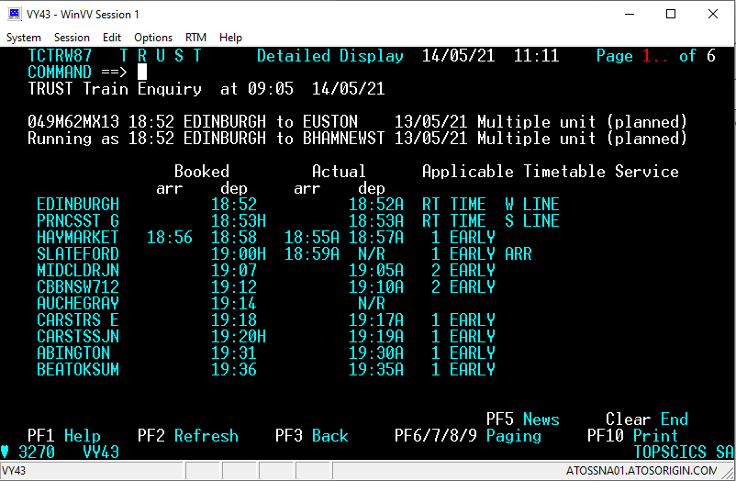

The lateness of the train, how the actual time at each location compares to the scheduled time, is shown here

If there is no time recorded, the entry shown will be ‘N/R’ (for Non-Report)

Stations where the train is booked to call show two scheduled times, one for arrival and one for departure

Locations of TRUST timing points, where the time of the train’s activity at that location is recorded. The activity could be originating, passing arriving, departing, terminating or being cancelled

**Recorded Delay Minutes**

It can be seen from the above that the train is scheduled to take 5 minutes to go from Abington to Beattock Summit (BEATTOKSUM). When (by the TRUST reporting,) a train takes 3 or more minutes longer than scheduled between delay reporting points, and is 3 or more minutes late, a **delay** must be recorded, along with the number of minutes and the reason for the delay. Note that not every TRUST timing point is a delay reporting point (some examples will be shown later).

If a train passes a delay reporting point 2 minutes early, and passes the next delay reporting point 2 minutes late, a delay need not be recorded even though the train took 4 minutes longer than scheduled between the two points. This is because going from early to on time is not counted as ‘delay’ only extra time that makes the train late is counted.

**Above Threshold/ Sub-Threshold Delays**

As above, if a train takes 3 or more minutes longer than scheduled between delay reporting points, a delay must be recorded. 3 minutes is the industry **threshold** for recording delays, all delays of 3 minutes or more must be investigated, and a reason recorded. Delays of less than 3 minutes are called sub-threshold, and may or may not be attributed to a cause. For a train going from 2 minutes early to 2 minutes late, a 2 minute delay may be recorded, but doesn’t have to be. Of course looking at the scheduled timings of the train compared to the actual times would reveal all the sub-threshold delays, even if they weren’t and attributed to a cause and recorded as delay minutes.

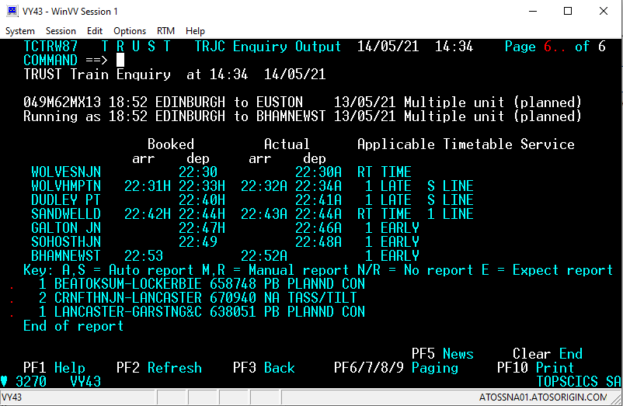

2-character incident cause code

6 digit incident number

Attributed delays for this train are shown at the bottom of the report (all sub-threshold delays in this case)

**Difference between Delay and Lateness**

A train’s **lateness** at any given location is how early or late it was relative to its scheduled time at that location. **Delay** in a section is how much extra time the train took to complete that section, relative to the time scheduled (excluding any recovery from early to on time).

Total attributed delay for a train is the sum of all the attributed delay minutes (shown above at the bottom of the Trust screen; 9M62 incurred 4 minutes of attributed delay. Note that since lateness can be recovered during the journey, 4 minutes attributed delay doesn’t mean the train terminated 4 minutes late. In this case 9M62 arrived at its destination 1 minute early. It is also possible for a train to terminate later than the total attributed delay would suggest, if it incurs sub-threshold delays which are not attributed to a cause.

Delay in a given section doesn’t necessarily equal the lateness at the end of that section. For example, a train could have 3 minutes delay in a section, but if that train was 5 minutes late entering the section, it would be 8 minutes late leaving the section having incurred the 3 minutes delay.

**TRUST Incidents**

When an above-threshold delay or reliability event (cancellation) occurs, it must be attributed to an **incident**, with an individual 6 digit incident number, a 2-character cause code categorising the type of delay, and a responsible organisation. Each separate and unconnected occurrence resulting in minutes delay and or reliability events has its own incident, which is set up by Network Rail staff.

An incident is a partly structured log entry describing the event and includes five particularly important fields: - • Incident Title (up to 30 characters) • Description Code (TRUST Delay Code/ Incident Cause Code) • Responsible Manager Code • Acceptance Status Code • Free format text (currently maximum of 30 lines).

The type of incident is coded using the incident code that best describes it. A list of incident cause codes is attached. The Responsible Manager Code consists of four characters. Normally the first coincides with the initial letter of the cause code. The middle two characters are known as the ‘Business Code’ and relate to the responsible organisation. There are separate ones for each Network Rail route, and each operator. The last reflect different managerial responsibilities within the organisation. The Network Rail Manager Code relates to the location of the incident.

**Example of part of an incident report in Trust:**

The summary at the bottom shows the total number of cancellations, trains affected and delay minutes (for all operators, not just Avanti). When the incident is imported into our next performance system (Bugle), only delay minutes to Avanti West Coast services are retained

The ‘HF’ in the responsible manager field indicates that the incident is the responsibility of Avanti West Coast. MHF7 is the code for Voyager fleet incidents

Avanti West Coast trains tilt when the track curves, to enable them to travel safely at faster speeds. This incident was caused by the tilt system on the train not working. This type of incident is represented by the incident cause code ‘NA’

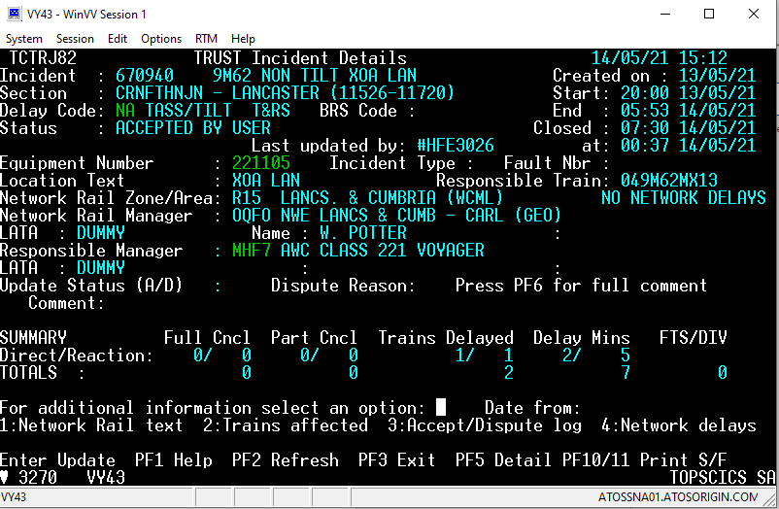

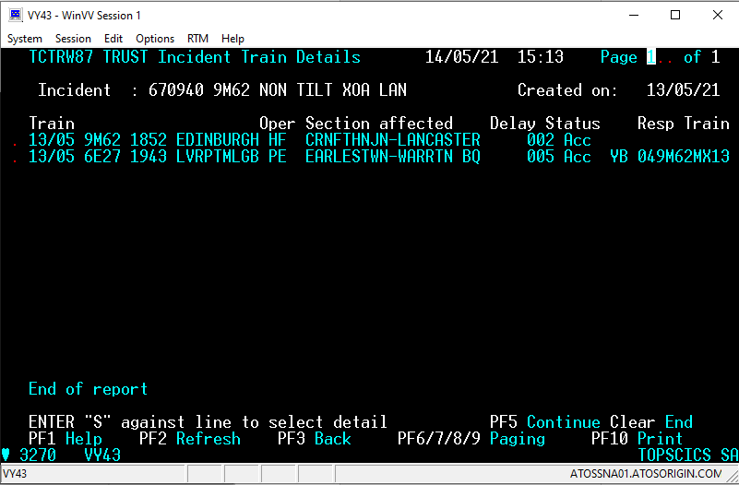

This 2-character code is present when the train isn’t delayed directly by the incident, but as a result of interaction with another train that has been delayed by the incident. We generally call these delays ‘Reactionary delays’, and the code is referred to as the (reactionary) Delay Cause Code, or ‘Y code’. When blank, the code is presumed to be the same as the Incident Cause Code. Otherwise, it always begins with a ‘Y’

The ‘HF’ indicates an Avanti service

This screen shows each train affected by the incident

Here shows the train ID for the train that caused the reactionary delay to the headcode listed. In this case, 9M62 was late due to running without tilting, which then caused a delay to 6E27, the train following 9M62 through Warrington. This information is lost when the incident information is imported into our next performance system (Bugle), however it is retained in Network Rail’s performance systems

**Difference between Primary and Reactionary Delay**

**Prime Cause**

The immediate cause or event that results in delay to a train is known as ‘Prime Cause’. Until a Prime Cause has occurred there will be no delay to a train service. ‘Prime Cause’ cannot be a reaction to a previous incident. In addition, where a delay is caused by a human error or oversight then that delay should be considered as a potential new ‘Prime Cause’.

**Direct Delay / Primary Delay**

A Direct (also known as Primary) Delay is a one that directly delays the train concerned, irrespective of whether the train was running to its schedule at the time the incident occurred, i.e. the delay is not a Reactionary Delay. Direct Delay should not be attributed to a Responsible Train or allocated a Y* Code. An example could be a train fault causing a train to run late, where only the delay to the train with the fault would be classed as direct/ primary delay. On the other hand, if a train fault caused the train to stop, blocking the line, primary delay would apply both to the train with the fault, and any trains that had to stop and wait for the train to be fixed before continuing. For a points failure, delays to the trains having to stop and wait while the points are fixed would be direct delays.

**Reactionary Delay**

A Reactionary Delay is a delay to a train that is the result of a prior delay to the same or any other train. Reactionary Delay should be attributed to the Responsible Train utilising the relevant Y* Code.

When an interaction between an already delayed train and another train causes a delay, that delay would be attributed as a reactionary delay to the incident that had caused the most delay to the latest train in the interaction (Primary and Reactionary Delay both included).

Where a train diverted from its scheduled line or platform causes a delay, Reactionary Delay is allocated to the incident that caused the diversion, irrespective of the lateness of the diverted train.

A list of reactionary delay cause codes (or Y-codes) is attached with the list of incident cause codes.

**Difference between Incident Location and Delay Location**

Incident Location is the location where the incident initially occurred. Usually this is the same location that the initial primary delays occurred. This is a free text field in Trust, so isn’t always consistent (e.g. one incident might have Incident Location as ‘Birmingham New Street’, another could have ‘BHM’, another ‘BhamNewSt’, where all these describe the same place). In our ‘Bugle’ performance system, there are other fields, called ‘Start Incident Section’ and ‘End Incident Section’, where the locations are always written in the same way, to help overcome this issue.

It’s common for incidents to cause delays far away from their initial occurrence, since interactions between trains can transfer reactionary delay around the network. For example, suppose an overhead line fault at Birmingham New Street caused a London Euston – Edinburgh via Birmingham New Street train to depart 90 minutes late. This train likely wouldn’t arrive in Edinburgh in time to start its next service on time, so there would be a delay at the start of the next service (which would be coded to the overhead line incident at Birmingham, with a ‘YI’ code representing late origin due to late inward stock). In this case the Incident Location would be Birmingham New Street, but the delay location would be Edinburgh. An incident has one initial Incident Location but can have many Delay Locations.

**KPIs**

Incident cause codes are often grouped together for reporting purposes. These cause code groups are called KPIs, where KPI stands for Key Performance Indicator. A list of KPIs and their definitions are attached. Our databases and Bugle performance system show which cause codes are in each KPI.

**Other Performance Systems**

**Bugle**

The TRUST system holds information about every operator’s trains, and all incidents. However, it only holds this information for a maximum of 14 days, before it is deleted (except incident information for incidents where the responsibility of the incident is in dispute, which is held indefinitely). It is also very difficult to interrogate and analyse data from TRUST due to the format.

For these reasons, we have another performance system, named ‘Bugle’. Each morning, all the information from Trust for Avanti Trains West Coast services for the previous day is imported into Bugle, with the exception of certain fields (e.g. ‘responsible train’ in relation to each reactionary delay, and total incident minutes to other operators’ services). Previous days can also be refreshed to account for any code changes that have since been made in TRUST.

Bugle holds information for 7 years, allows responsible managers to accept delays with more detail, reject them to Network Rail or refer them internally to other responsible mangers, and also allows relationships and groups to be set up and maintained to aid reporting, such as headcode groups, cause code groups, etc.

As mentioned earlier, timings in Bugle are rounded down to the nearest minute.

**Acumen BI**

Acumen BI enables reporting on the data stored in Bugle. Reports can be set up and customised with chosen fields and filters, and can also be set up to be emailed automatically to distribution lists at regular intervals for a chosen time period. Some example reports from Acumen are attached, showing the type of data that can be exported.

**First Group DataHub**

This relatively new system contains timing and delay attribution information for all First Group operators. For many locations, it contains data to the nearest second, either from the data source that feeds TRUST before it is truncated to the minute, or from GPS data, or both. The Sub-Threshold Delay Report is an example of a Power BI report produced using this data. It can also be used to look at dwell times in more detail, more detail by section, etc. An image of the Sub-Threshold Delay Report is attached.

Power BI connects to the data via Amazon Redshift. A schema for the First Group DataHub is attached.

**Vortex**

Our trains have OTMR (also known as OTDR, data recorders or incident recorders), which record information about the state of the train and the actions taken by the driver. OTMR stands for On Train Monitoring Recorder (OTDR is the same but the D stands for Data).

Key details recorded are whether the cab is occupied, the speed of the train, whether the doors are locked, when power is selected, when the brake is selected, when the train receives a warning for a restrictive signal, when the driver reacts to such a warning by pressing a button, whether the train is able to tilt, when the Wheel Slip Protection system is activated, when the emergency brakes are activated, etc.

This information is remotely downloaded from each train overnight where possible, and stored in a Microsoft SQL database. Vortex is a system that allows us to query and visualise this data. An example of a typical train running graph from Vortex is below, showing the speed of the train over time (among other channels).

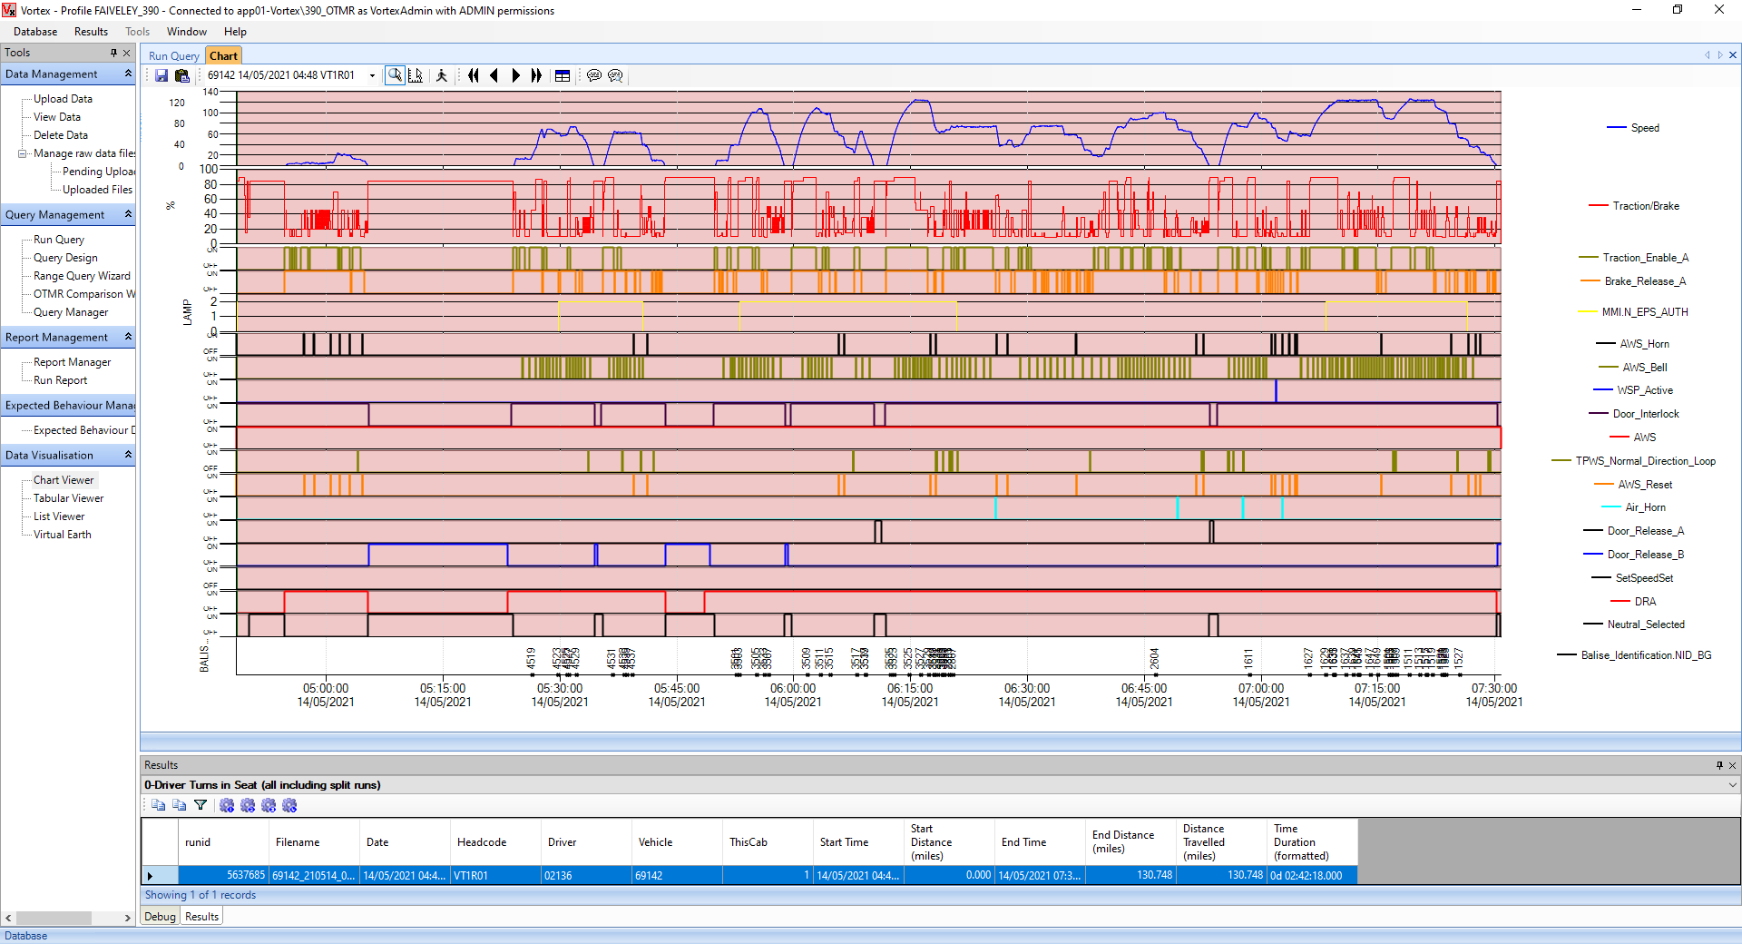

**ITED**

ITED stands for Industry Train Event Data. This is a Network Rail system which contains data for all operators accurate to the nearest second, either from the data source that feeds TRUST before it is truncated to the minute, or from GPS data, or both. It is linked to the schedule information for each train, and is provided more regularly than at TRUST delay reporting points – it is also provided at each berth*, allowing for detailed analysis at a granular level, for example to see the full effect of temporary speed restrictions.

* a ‘berth’ is an area usually representing a signal. At stations, ‘berth offsets’ are used to estimate the time between leaving the last berth and arriving at the station.

**Definitions of Cancellation types**

There are different types of cancellation events a train might incur. Definitions of these are below:

|  |  |
| --- | --- |
| Cancellation type | Definition |
| Cape | Train cancelled throughout, ran no part of the journey |
| Pine | Train terminated before reaching its booked destination |
| Calvin | Often shortened to calv. Train started further along the route than its booked start location |
| Calpin | This term is used for a train that is both a pine and a calvin, i.e. it started further along the route than its booked start location, and was terminated before reaching its booked destination |
| FTS | Stands for Fail To Stop. This is the term for when a train fails to call at a station it is booked to call. Any stations not called at due to a pine or a calvin do not fall into this category, however if a station was missed mid-journey (could be due to a station security incident, or a train booked to go from Euston to Scotland via the West Midlands going via the Trent Valley instead to recover time), these would be FTS. A train can have several FTS in the same journey |
| DfT Full Cancellation | When a train runs less than 50% of its booked mileage, it counts as a full cancellation for the DfT (and for cancellations measures described later). All capes are automatically DfT Full Cancellations, but some pines and calvins may be too |
| DfT Part Cancellation | When a train is partially cancelled (e.g. a pine, calvin or FTS), but runs more than 50% of its booked mileage. In the cancellations metrics described later, a DfT Part Cancellation counts as half a cancellation |

**Definitions of and Performance Metrics**

As well as using delay minutes, and incident numbers etc. to tell us about our performance, there are several other ‘Performance Metrics’ that we are currently or have previously been measured against.

Some of these, along with their definitions, are shown below.

|  |  |
| --- | --- |
| **Metric** | **Definition** |
| On Time | Percentage of recorded stops (origins, arrivals and termini) that were less than 1 minute later than scheduled. Note cancelled stops are not included in this percentage, and not counted as a recorded stop |
| T-3 | Percentage of recorded stops that were less than 3 minutes later than scheduled |
| T-15 | Percentage of recorded stops that were less than 15 minutes later than scheduled |
| T-x | Percentage of recorded stops that were less than x minutes later than scheduled |
| PPM | Public Performance Measure. Percentage of booked trains that arrived at destination less than 10 minutes late (trains with any kind of cancellation count as PPM failures) |
| CaSL | Cancelled And Significantly Late. Percentage of booked trains that either had any kind of cancellation, or arrived at destination 30 minutes late or more |
| TOC on Self Cancellations | Percentage of booked trains that were cancelled due to TOC on Self responsibility causes. For this measure, a DfT Full Cancellation counts as 1 cancellation, and a DfT Part Cancellation counts as half a cancellation. Cancellations approved by the DfT as ‘Service Recovery’ (cancelled in order to recover the service and reduce delay on the network), are not counted as cancellations under this measure |
| All Cancellations | Percentage of booked trains that were cancelled due to any cause. For this measure, a DfT Full Cancellation counts as 1 cancellation, and a DfT Part Cancellation counts as half a cancellation. |
| TOC on Self Delay per 1000 Train Miles | Above threshold delays due to TOC on Self Responsibility causes, divided by number of train miles/1000. Excludes delays to partially cancelled trains |

**Appendices**

1 Avanti West Coast route map

2 Avanti West Coast stations and Codes

3 Incident and Delay Cause Codes (from DAPR)

4 KPI Descriptions

5 Example Incident Overview Report from Acumen

6 Example Customised List of Delays Report from Acumen

7 Example Journey Report from Acumen

8 Example Lateness by Date, Train and Location Report from Acumen

9 Example Punctuality Metric Report from Acumen

10 Sub-Threshold Delay Summary Report

11 DataHub Schema

12 Jargon Buster